**Project Description**

Name: Analysis of Coffee Shop Sales and Consumer Preferences

Problem Statement:

The coffee industry continues to grow as consumer preferences evolve. Understanding sales trends, purchasing behaviors, and product performance is crucial for coffee shop owners to optimize their business strategies. This project aims to analyze transaction-level data from coffee shops to uncover patterns in sales quantity, product performance, store performance by location, and pricing. The analysis will also explore peak sales times and consumer preferences for different types of coffee products.

Possible Impact of Your Analysis:

* Identifying top-performing product categories and products to optimize inventory management and marketing efforts.
* Determining the best-performing store locations to guide future location-based decisions.
* Analyzing sales patterns based on time and date to enhance staffing and promotional strategies.
* Offering insights into pricing strategies to increase profitability.

Dataset(s):

* Source: <https://www.kaggle.com/datasets/ahmedabbas757/coffee-sales>
* Size: (8.97 MB)
* Transactions: Row (149116) | Column (11)
* **Description**:  
  This dataset contains transaction records for **Maven Roasters**, a fictitious coffee shop operating out of three NYC locations. It includes details such as transaction date, timestamp, and store location, along with product-level information like product category, type, unit price, and quantity sold.
* transaction_id: Unique sequential ID representing an individual transaction
* transaction_date: Date of the transaction in MM/DD/YY format
* transaction_time: Timestamp of the transaction in HH:MM:SS format
* transaction_qty: Quantity of items sold in the transaction
* store_id: Unique identifier of the coffee shop where the transaction took place
* store_location: Location (city/region) of the coffee shop
* product_id: Unique identifier for the product sold
* unit_price: Retail price per unit of the product
* product_category: Broad category of the product (e.g., coffee, pastries)
* product_type: Specific type of product within a category (e.g., latte, croissant)
* product_detail: Detailed description of the product (e.g., size, flavor)

Project Scoping Document

## Name: Coffee Shop Sales Analysis

## Business Problem

The coffee shop industry is highly competitive, and understanding key business drivers like sales trends, product performance, and customer preferences is crucial. Analyzing transaction data can uncover actionable insights to help optimize inventory management, improve marketing strategies, and enhance store operations.

## Business Impact

* Increase revenue by identifying best-selling products and underperforming items.
* Optimize inventory and supply chain management by understanding sales patterns and peak demand periods.
* Improve customer satisfaction and retention by tailoring product offerings and promotional strategies.

## Support decision-making on store locations and operational efficiency.

## Dataset(s)

**Strengths**:

* Comprehensive transaction-level data for sales analysis.
* Includes geographic performance information for store comparisons.
* Detailed product-level breakdown enables product performance tracking.

**Weaknesses**:

* No customer demographic data to analyze buying behavior across different segments.
* Lacks external variables such as promotions or seasonal trends that influence sales.

## Methods

## **Time-based analysis:**

## **Use transaction_date and transaction_time to analyze sales trends over time.**

## **Identify peak sales hours and seasonal patterns to optimize staffing and inventory.**

## **Product performance:**

## **Analyze product_category, product_type, and product_detail to determine the best- and worst-performing products.**

## **Compute metrics such as total revenue per product, average unit price, and sales volume.**

## **Store performance:**

## **Compare revenue, transaction counts, and average sales per transaction across store_id and store_location.**

## **Price and quantity relationships:**

## **Assess the correlation between unit_price and transaction_qty to analyze pricing strategies' impact on sales.**

## **Statistical Techniques**

## Use **descriptive statistics** to calculate:

## **Average sales per transaction**

## **Sales variance**

## **Revenue growth rate** over time

## Apply **trend analysis** to detect upward or downward patterns in sales.

## Use **correlation analysis** to explore relationships between product pricing and sales volume.

**Software and Tools**

* **Data Cleaning and Analysis**: Python (pandas, NumPy), SQL
* **Visualization and Dashboard**: Tableau for creating interactive dashboards and Excel for preliminary charts and insights

## Dashboard

* **Overall Sales Performance**: Display total revenue, average transaction size, and number of transactions.
* **Sales Trend Over Time**: Line chart showing sales by date and time to identify peak periods.
* **Top-Selling Products**: Bar chart highlighting the best and worst-performing products.
* **Store Performance**: Location-based visualization comparing revenue and transaction counts across stores.

*[You can also include a picture of a hand-drawn sketch of the dashboard to show us that you have thought about what your final product will look like]*

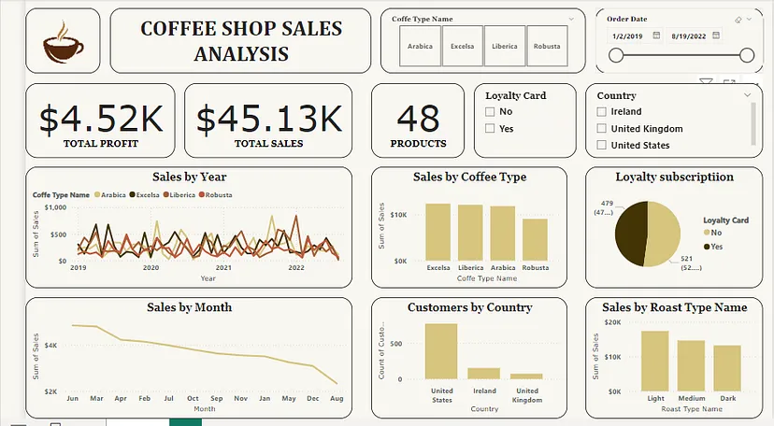

## Milestones

1. **Week 1**: Define project scope and explore dataset structure
2. **Week 2**: Perform data cleaning and preprocessing
3. **Week 3**: Conduct exploratory data analysis and identify trends
4. **Week 4**: Develop visualizations and build an interactive dashboard
5. **Week 5**: Finalize the project report and prepare the presentation

## 

## Timeline

|  |  |
| --- | --- |
| Week | Tasks |
| Week 1 | |  | | --- | | Define the business problem, scope project, and explore the dataset |  |  | | --- | |  | |
| Week 2 | |  | | --- | | Clean and preprocess data |  |  | | --- | |  | |
| Week 3 | |  | | --- | | Perform exploratory data analysis |  |  | | --- | |  | |
| Week 4 | Build and refine the dashboard |
| Week 5 | |  | | --- | |  |  |  | | --- | | Create final report and presentation | |